@base directive provides URI to complement all relative URIs

@prefix dbo: <<https://dbpedia.org/ontology/>> .

@base <<http://dbpedia.org/resource/>> .

<Pluto> dbo:discovered “1930” .

<Pluto> dbo:discoverer <Clyde_Tombaugh> .

Instead of using the link we use <Pluto>

It cal also be reduce

@prefix dbo: <<https://dbpedia.org/ontology/>> .

@base <<http://dbpedia.org/resource/>> .

<Pluto> dbo:discovered “1930” ;

dbo:discoverer <Clyde_Tombaugh> .

If you have same subject and same predicte use the comma (,)

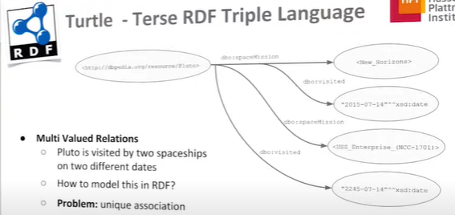

If the planet Pluto has been visited two times by two missions, how can we associate Mission1 to Date1 and not to Date2 of the second mission? **Use blank nodes**, it can denotes two space mission and to each we can associate a mission and a date

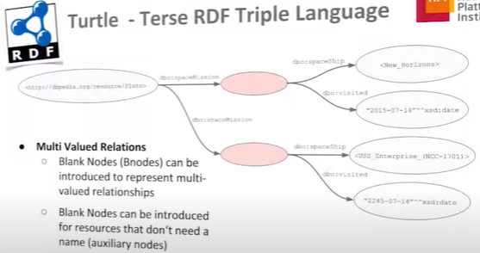

blank nodes can be use to represent multi valued relationship

* Container: open list, an extension is possible
* collections: closed list, no extension is possible after they are defined